|  |
| --- |
|  |
| Capstone Project Document |

**DANDELION**

|  |  |  |
| --- | --- | --- |
| **Dandelion** | | |
| **Group Members** | Vũ Công Chính | SE02585 |
| Lưu Ngọc Mạnh | SE02619 |
| Nguyễn Minh Huy | SE02723 |
| Dương Đức Anh | SE02700 |
| Vũ Ngọc Trung | SE02967 |
| Cao Thị Phương Mai | SE02908 |
| **Supervisor** | Mr. Nguyễn Văn Sang | |
| **Project code** | DDL | |

**- Hanoi, 09/2015 -**

TABLE CONTENTS

1 Introduction 3

1.1 Purpose 3

1.2 Project Information 3

1.3 The people 3

1.3.1 Supervisor 3

1.3.2 Team members 3

1.4 Abstract 3

1.5 Background 4

1.6 Proposal 5

1.6.1 The idea 5

1.6.2 The objective 5

1.6.3 Brief description about system 6

1.6.4 System features 7

1.7 BENEFIT FROM PROJECT 8

1.7.1 For our group 8

1.7.2 For Community 8

1.8 CRITICAL ASSUMPTION AND CONSTRAINTS 8

1.9 POTENTIAL RISKS 9

2 Project management 10

2.1 Project Process 10

2.1.1 FPT Software Process Model 10

2.1.2 Project Life Cycle 11

2.2 Project Organization 12

2.2.1 Organization Structure 12

2.2.2 Project Team 12

2.2.3 Infrastructure 13

2.3 Project management plan 14

2.3.1 Task 14

2.3.2 Meeting minutes 15

2.3.3 Coding convention 16

2.3.4 Risk management plan 16

2.3.5 Communication plan 16

2.3.6 Configuration Management Plan 18

**Acknowledgements**

D

uring the implementation of this project, we have received overwhelming support from a number of people, to whom we would like to express our great appreciation. Without them, this project would have been done with much more obstacles than it was.

First and foremost, we would like to show our thankfulness to Lecturer Nguyễn Văn Sang, our supervisor of this project during four months and and teacher Nguyen Cuong, specialized consultants, who taught us Japanese. They have given us not only many valuable advices but also enthusiastic inspirations that helped raising our team members’ spirit to give us the possibility to complete this Capstone Project.

Last but not least, we are thankful to our families, our teachers and our friends in FPT University for their constant encouragement and support throughout this project.

# Introduction

## Purpose

This part of document is the introduction for project Dandelion – our Capstone Project at FPT University. In this document, we will descript the overview of some existing systems, the initial idea for our project, a brief description about our expected system and some potential risks, critical assumptions, constrains. Moreover, this document also shows opportunities what it offers for users.

## Project Information

* Project name: Dandelion
* Project code: DDL
* Project group name: Dandelion
* Product type: Website Application
* Timeline: from 07th September to 21st December 2015

## The people

### Supervisor

|  |  |  |  |  |
| --- | --- | --- | --- | --- |
|  | Full name | Phone | Email | Title |
| Supervisor | Nguyễn Văn Sang | 0912210727 | Sangnv@fpt.edu.vn | Lecturer |

1. Supervisor’s information

### Team members

|  |  |  |  |  |
| --- | --- | --- | --- | --- |
|  | Full name | Phone | Email | Role |
| 1 | Lưu Ngọc Mạnh | 0973232734 | manhlnse02619@fpt.edu.vn | Lecturer |
| 2 | Vũ Công Chính |  |  |  |
| 3 | Nguyễn Minh Huy |  |  |  |
| 4 | Dương Đức Anh |  |  |  |
| 5 | Vũ Ngọc Trung |  |  |  |
| 6 | Cao Thị Phương Mai |  |  |  |

1. Team member’s information

## Abstract

We’re a home for everything from films, games, and music to art, design, and technology. Dandelion is full of projects, big and small, that are brought to life through the direct support of people like you. Dandelion is a platform and a resource; we’re not involved in the development of the projects themselves. Anyone can launch a project on Dandelion as long as it follows our rules. Project creators set a funding goal and deadline. If people like a project, they can pledge money to make it happen. Backers are supporting projects to help them come to life, not to profit financially. Instead, project creators offer rewards to thank backers for their support. We believe that creative projects make for a better world, and we’re thrilled to help support new ones. Building a community of backers around an idea is an amazing way to make something new.

## Background

There are quite a few major platform for crowdfunding your project idea. However just have one crowdfunding in Vietnam and that major platform just aim to comic project. For example: kickstarter.com, comicola.com, indiegogo.com, etc.

* **Kickstarter**

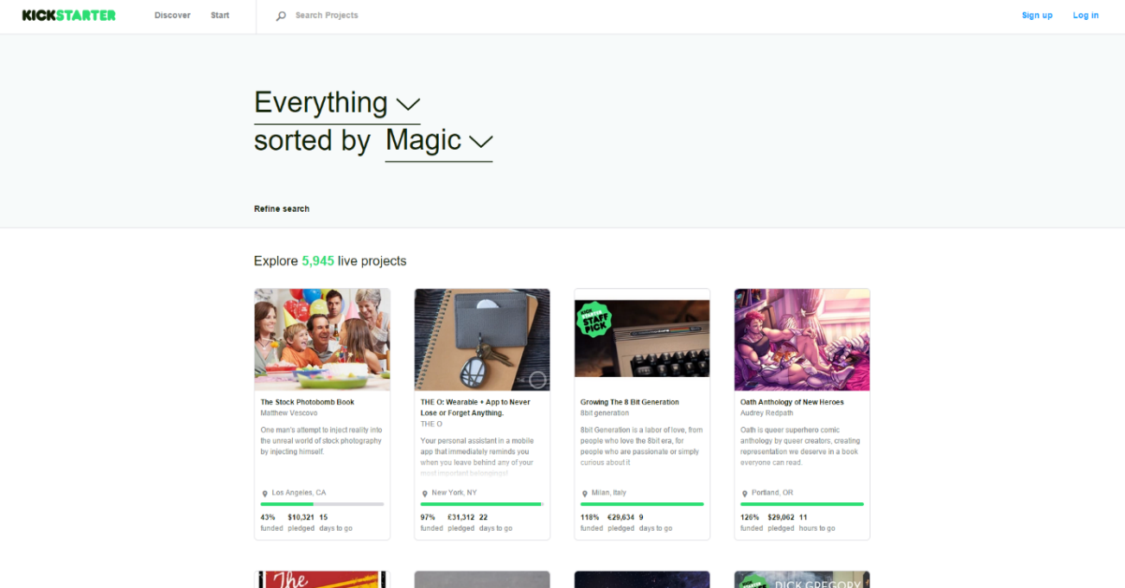

**Figure 1-1:** Website Kickstarter

Kickstarter is the biggest major platform for crowdfunding your project idea, users can create a project, Kickstarter staff look at your proposed project and provide feedback. Then they (hopefully) approve your project and it’s posted on the site. If that project don’t hit the funding goal in the specified time frame, no one’s cards get charged and user don’t receive any of the funds.

* **Advantages:**
* The biggest major platform for crowdfunding
* Kickstarter positions itself mostly as a community for creative projects.
* Kickstarter staff provide feedback to help your project succeed.
* **Disadvantages:**
* You have to be based in the US, Canada, the UK, Australia, New Zealand or the Netherlands.
* Only support PayPal, MasterCard, etc. These are not popular in Vietnam.
* **Comicola**

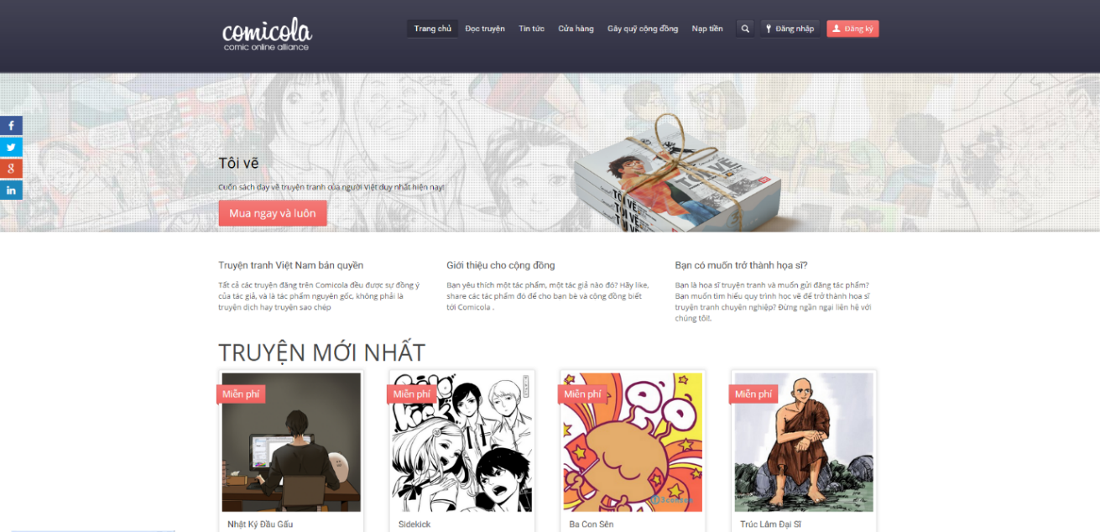

**Figure 1-2:** Website Comicola

Comicola is a major platform for crowdfunding your comic project idea in Vietnam.

* **Advantages:**
  + Has friendly user interface – Vietnamese.
  + Making payments easier for creators and backers.
* **Disadvantages:**
  + Just for comic project.

## Proposal

### The idea

Nowadays people have a lot of idea to make things better. But lots of people are short of funds to raise their idea. Many thanks for internet they can easy to show these ideas to everyone.   
Our project – Dandelion is a major platform for crowdfunding. Anybody could launch a project on Dandelion as long as it follows our rules. We believe that creative projects making a better world, and we’re thrilled to help support new ones. Building a community of backers around an idea is an amazing way to make something new.

### The objective

This project is the Capstone Project in FPT University studying program.

First, this project is responsibility for all team members. So we must complete all requirements from teacher and FU. During the time doing project, we can learn how to develop a project, how to manage project, how to communicate better between team member, how to control time, how to perform teamwork effectively. Moreover, we also have experience in .NET technology, website designing, software testing Therefore, we think this project is very necessary for us to improve skills, knowledge which we studied in FU. This project also makes our CV more beautiful after graduating from FU. This is also an opportunity for us to prove capacity with recruiters.

Second, because we’d love to support people’s dream, especially Vietnamese users to create something that they want to see exist in the world. Everything from films, games, and music to art, design, and technology. And we want to build a community where people rally around their friends’ projects, fans support people they admire, and others simply come to DDL to be inspired by new ideas. Anyone can create a new project, update, share a project to social network or back a project. Specially, our website can display completely in Vietnamese, so that even users do not know English, they can easily use it.

### Brief description about system

This software is a major platform for crowdfunding with friendly and attractive interface, users can easily find out interesting project to back or create a new project with their idea. User also can send opinion to admin if they need help.

DDL uses familiar technologies as: Bootstraps, .NET MVC5, AngularJS… And we are planning to develop a mobile version for easily connecting.

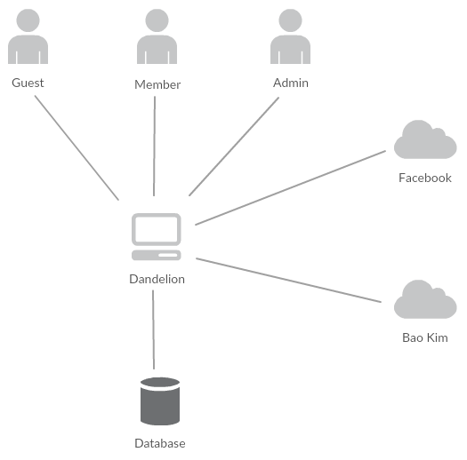

1. Brief descriptions diagram of DDL system

### System features

About the features of DDL, we focus to provide for users main features as searching, filter project, create new project, back project, etc. Admin can manage members, manage projects, manage database, manage contribute database and manage Q&A.

In here, we focus on features which can help users can understand the best way what user want to have with features of DDL. There are the detailed features of DDL:

#### Client features

* Register: User can register an account and login to use all features of DDL.
* Login/Logout: Users login/logout an account to use or exit system DDL.
* Search: User and guest can search with code of project, name of project, name of creator; and system will display all of project relate to keywords.
* Filter: User can filter with category (Art, Comics, Game, etc.), Status (Popularity, Most Funded, etc.). And system will display projects relate to these selected options.
* Project
  + Create New Project: Users can create new projects with basic info, reward, timeline, clip and some pictures.
  + Update Project Information: User can change and update information of projects which created.
  + Comment/Remind: Users can comment/remind a project to follow and discuss with another users.
  + Report: User can report a project which violate regulation to administrator.
* Back Project: User can back another project to donate money to help project success and get rewards.
* Profile:
  + Change password: User can change password to keep security.
  + Update profile: User can change or update information.
  + Manage created projects, backed projects, reminded projects: User can follow process of projects, follow project backed, project reminded. View statistical projects had created, backed, reminded.
  + Sent/Receive message: Users can send to or receive from other users to discuss about projects.

#### Admin features

* Manage user:
  + Search user: Admin can search with name of user and system will display simple information about that user(name, email, phone number)
  + Inactive/active user: admin can set user’s account to inactive or active.
* Manage project:
  + Search project :
    - Search with project name: Admin can search with name of project and system will display simple information about that project.
    - Search with category: Admin can search with category of project and system will display all project with that category
    - Search with Creator name: Admin can search with Creator name of project and system will display all project of that user.
  + Edit project status: Admin can set status of a project: pending to approved, pending to suspend, approved to suspend, etc.
* Manage Backing:
  + Admin can view users who backed a project. Also, Admin can view simple information about that user and which reward they chose.
* Manage Categories:
  + Add new category: Admin can add new category.
  + Inactive/active category: Admin can set category’s status to inactive or active
* Manage Slider: Slider list includes images what running at homepage.
  + Add new image: Admin can add new image to slider
  + Inactive/active: Admin can set image’s status to inactive or active on slider.
  + Delete image: Admin can delete image.
* Message: Admin can view received messages/sent messages.
  + Compose new message: Admin can compose new message to send to user.
  + Delete message: Admin can delete received messages/sent messages.

## BENEFIT FROM PROJECT

### For our group

After developing and implementing this project, our group will get some benefits:

* Have more experiences of software project management how to manage plan, time, member and risk.
* Have more knowledge and skill about .NET MVC5 and AngularJS programming
* Know how to communicate with team members and how to teamwork more effective.

### For Community

Just need to have a device that connect to the internet and any web browser, user can:

* Easy join to a community of crowdfunding
* Easy search for interesting project information and back them
* Easy to start a new project idea

## CRITICAL ASSUMPTION AND CONSTRAINTS

* Critical assumption:
  + Training: All developers can train .NET and AngularJS in 2 weeks. Before starting this project, just 1 member in our team have knowledge about .NET and no one have knowledge about AngularJS, but with programming techniques which we studied at FU, we have to try the best to not missing any deadline in project plan.
  + Human resources: Assume that all members in team have a good healthy to do their tasks.
* Constraints:
  + Time and deadline: We must complete task on time. We work on 14 weeks, each member works 5 hours/day and 5 days/week. We do not have more time for us to complete developing and deliver application to teachers. Besides, we have to submit report documents before deadline to teacher can review.
  + Quality: The products must be run well when users perform main functions in Google Chrome 40 and Firefox 30 or higher.
  + Process: We have to follow the software processing of FPT Software
  + Human resources: There are 6 member in our team, each member have to study 2 subjects (Japanese and JFE) at school.

## POTENTIAL RISKS

After studying about this project, we find out some problem that we may be encountered:

* Under-estimate scope and time or miss deadline because lack of experience in group working, managing and controlling work.
* Loss data, source code before uploading data to server because of careless.
* Equipment got broken because of careless or accident.
* Human resources: Team member cannot complete their works because of health reasons, key member leave team or un-cooperating on team.
* Change requirements: Requirement changed when some functions cannot be completed or some technologies is not suitable

# Project management

## Purpose

This part is the project management plan of Dandelion (DDL) Project – our Capstone Project  
in FPT University. It is included the project overview, project organization, tools and  
infrastructures, schedule of this project.

## Project Process

Process of this project is performed follow to Software Development Process of FPT Software.

### FPT Software Process Model

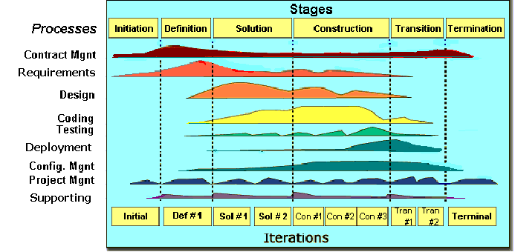

1. FPT Software process model

The software lifecycle is broken into *cycles*, each cycle working on a new generation of the product. The FPT Software process divides one development cycle in six consecutive *phases*:

1. Initiation phase
2. Definition phase
3. Solution phase
4. Construction phase
5. Transition
6. Termination

### Project Life Cycle

Basing on FPT Software process and real-world project, we decided to divide the project into 4 phases: Initiation, Solution, Construction, and Termination:

* **Initiation Phase:** This is the explanatory phase of the project. Project objective and description is described at this stage. The purpose of this phase is to collect and understand business requirements, detail the project plan and agree upon a high level statement of work. Our primary objectives are complete project identification and project plan. After these are completed, the project is checked against the following criteria:
  + Identify business functions of the system
  + Determining the scope, conditions and limitations of the project
  + List the main functions of the system
  + List one or more suitable architecture for the system
  + Identify project risks
  + Complete Report #1, and Report #2
* **Solution Phase**: In this phase, the architecture of the system is designed. The goal is to translate requirements and specification into a technical solution to produce Technical Design.
  + Ourprimary objectivesare completeRequirement Specification, Architecture Design and Database Design.
  + Finally, the plan must be provided (including estimates of cost and time) for the construction phase. The plan must ensure proper and accurate based on experience.
  + Complete Report #3 and Report #4
* **Construction Phase**: This is the longest phase of a project life cycle.
  + In this phase, all functions of the system will be installed. The installation will be divided into small stages, each stage of the installation a few functions. The results of each phase will be the release of the module function can be executed.
  + Construction and improvement of products until the final product is ready to deliver to the user. During this phase, all the components and other features of the application is developed and integrated into the product.
  + This phase emphasizes the resource management and control operations to optimize cost, time and quality.
  + Complete software packages and Report #5, Report #6
* **Termination Phase**: This is the final phase in the life cycle of a project.
  + Their products will be deployed to the client. The feedback received during the transfer process will be recorded and put on the new functional requirements or functionality enhancements in the next version of the product.
  + Phase transfer switch also includes the training system and the new system for the user.

## Project Organization

### Organization Structure

1. Organization Structure

### Project Team

|  |  |  |  |  |  |
| --- | --- | --- | --- | --- | --- |
| Role | Responsibility | Full name | Effort (%) | Start date | End date |
| PM | Have overall responsibility of the project:  - Project planning and scheduling  - Task assignment and tracking processing  - Review documents  - Reporting to supervisor | Luu Ngoc Manh | 50 | 07-09-2015 | 25-12-2015 |
| PTL | PTL is responsible for the technical project execution | Luu Ngoc Manh | 50 | 07-09-2015 | 25-12-2015 |
| Programmer #1 | - Study technique (C#, MVC, AngularJS, etc.)  - Coding functions and modules of system.  - Peer-review source code of others members | Nguyen Minh Huy, Vu Ngoc Trung, | 100 | 07-09-2015 | 25-12-2015 |
| Programmer #2 | - Support coding functions and modules of system. | Duong Duc Anh | 50 | 07-09-2015 | 25-12-2015 |
| Programmer #3 | - Support coding functions and modules of system. | Cao Thi Phuong Mai | 100 | 07-09-2015 | 30-10-2015 |
| Test Leader | - Create test plan, test case, test report, quality report  - Execute test. | Cao Thi Phuong Mai | 100 | 30-10-2015 | 25-12-2015 |
| Tester | - Support creating test plan, test case, test report, quality report  Execute test. | Vu Cong Chinh | 100 | 30-10-2015 | 25-12-2015 |
| Design  Lead | - Create screen design, prototype  - Review design of others member | Vu Cong Chinh | 100 | 07-09-2015 | 25-12-2015 |
| Designer #1 | - Support creating screen design | Duong Duc Anh | 50 | 07-09-2015 | 25-12-2015 |

1. Project Team description

### Infrastructure

|  |  |  |  |
| --- | --- | --- | --- |
| Item | Description | Expected Availability by | Note |
| Development Environment | | | |
| Operating System | Window 8.1 (32 bit, 64 bit) |  |  |
| Browser | Chrome (40 or above), Firefox (30 or above) |  |  |
| Development language | .NET C# |  |  |
| Technology | | | |
| Development language | .NET C#, MVC Model, AngularJS |  |  |
| Database | SQL Server 2012 |  |  |
| Hardware Requirement | | | |
| Hardware Configuration | 2GB workspaces on server |  |  |
| Equipment & Tools | | | |
| Source Version Control | TortoiseGit | Definition stage |  |
| Task Tracking | MS Project Professional 2013 | Initiation stage |  |
| SRS | Microsoft Office Word 2013, Microsoft Office Excel 2013, Microsoft Office Visio 2013 | Initiation stage |  |

1. Infrastructure

## Project management plan

### Task

Refer to DDL_Project_Schedule_v1.0_EN.mpp for more detail

|  |  |  |  |  |
| --- | --- | --- | --- | --- |
| No | Stage | Committed Delivery date | Description of Deliverable | Delivery media |
| Initiation | |  | Requirements agreed, Report 1 reviewed | |
| 1 | Develop project idea | 08-09-2015 | Project goals and scope defined, milestone description defined, resource committed |  |
| 2 | Q&A Management Sheet | 14-09-2015 | Criteria: Documentation reviewed |  |
| 3 | Submit report no.1 final | 22-09-2015 | Completed report no.1 |  |
| 4 | Project Plan | 21-09-2015 | Criteria: Documentation reviewed |  |
| 5 | Submit report no.2 final | 19-10-2015 | Completed report no.2 |  |
| Solution | |  |  | |
| 1 | Screen Prototype | 05-10-2015 | Criteria: Documentation reviewed |  |
| 2 | Architecture Design | 08-10-2015 | Criteria: Documentation reviewed |  |
| 3 | Screen Design | 09-10-2015 | Criteria: Documentation reviewed |  |
| 4 | Class Design | 16-10-2015 | Criteria: Documentation reviewed |  |
| 5 | Detail Data Design | 05-10-2015 | Criteria: Documentation reviewed |  |
| 6 | SRS | 28-09-2015 | Criteria: Documentation reviewed |  |
| 7 | Submit Report no.3 Final | 28-10-2015 | Completed report no.3 |  |
| 8 | Submit Test Plan Final | 28-10-2015 | Criteria: Documentation reviewed |  |
| 9 | Create Test Case | 12-11-2015 | Criteria: Documentation reviewed |  |
| 10 | Submit Report no.4 Final | 25-11-2015 | Completed report no.4 |  |
| Construction | |  | Product developed & tested and released to supervisor, documentation reviewed. | |
| 1 | Review Test Document | 12-11-2015 | Criteria: Documentation reviewed |  |
| 2 | Submit report no.5 Final | 10-12-2015 | Completed report no.5 |  |
| 3 | Complete Coding and Unit Test | 24-11-2015 | Source code  Acceptance criteria: Product unit tested |  |
| 4 | Complete Testing | 04-12-2015 | Completed Test |  |
| 5 | Submit report no.6 Final | 14-12-2015 | Completed report no.6 |  |
| 6 | Submit the last document and CD source code | 15-12-2015 | Final Documents and Source Code |  |
| Termination | |  | Project post-mortem is conducted, Project assets archived and released to supervisor | |
| 1 | Lesson learned | 11-12-2015 | Criteria: Completed |  |
| 2 | Complete Presentation Slide | 14-12-2015 | Criteria: Completed |  |
| 3 | Represent capstone project | 20-12-2015 | Criteria: Completed |  |
| 4 | Project Complete | 21-12-2015 | Criteria: Completed |  |

1. Project Milestone and Deliverables

### Meeting minutes

All meeting minutes will be written follow this template

|  |  |  |  |  |  |  |
| --- | --- | --- | --- | --- | --- | --- |
| Project: | | Dandelion | | Project Code: | DDL | |
| Project Manager: | | Lưu Ngọc Mạnh | | Conductor: | Nguyễn Văn Sang | |
| Secretary: | Lưu Ngọc Mạnh | |
| Date: | | 16/09/2015 | | Time: | 12:30 PM – 01:00 PM | |
| Venue: | | FPT University | | | | |
| Topic of meeting: | | Weekly Project Meeting | | | | |
| Attendees: | | | | | | |
| No | Full name | | Unit/Group | Position | | Attendance |
| 1 | Nguyễn Văn Sang | | FPT | Introductor | | Present |
| 2 | Lưu Ngọc Mạnh | | JS | PM | | Present |
| 3 | Vũ Công Chính | | JS | Team Member | | Present |
| 4 | Nguyễn Minh Huy | | JS | Team Member | | Present |
| 5 | Dương Đức Anh | | JS | Team Member | | Present |
| 6 | Cao Thị Phương Mai | | JS | Team Member | | Present |
| 7 | Vũ Ngọc Trung | | JS | Team Member | | Present |

1. Objectives
2. Agenda
3. Contents

### Coding convention

### Risk management plan

### Communication plan

|  |  |  |  |  |
| --- | --- | --- | --- | --- |
| Communication Type | Method/Tool | When | Information | Participants/ Responsible |
| Project Task Tracking | | | | |
| Task scheduling | MS Project Professional 2013 | At the beginning of every stage, and weekly  Refinement and rescheduling as necessary |  | PM |
| Task assignment | MS Project Professional 2013 | Weekly |  | PTL |
| Task status reporting | Daily Report | Daily |  | Project Team members |
| Project Meeting | | | | |
| Kick-off Meeting | Face to face | Initiation stage | Project introduction; Project plan review; Risk identification; stakeholders identify. | PM, Project Team Members |
| Project Progress Review Meetings | Face to face | Weekly and on event | Communicate project status  Communicate and resolve any open issue, risks, and changes  Discuss any suggested improvement | PM, Project Team Members |
| Milestone Meetings | Face to face | 5 days after the completion of stages: Definition, Solution & Construction | Project objective review, evaluate project performance (quality, schedule, effort), Causal analysis, update project plan for next stage | PM, Project Team Members, QA, Supervisor |
| Supervisor Communication and Reporting: | | | | |
| Communication with Supervisor | | | | |
| Transfer/Sharing of project documentation/information | TortoiseGit | When available | All project documentation and information | PM, Project Team Members, QA |
| Project Report | Agreed FPT Software and FU standard format | 5pm Monday, Weekly | Project status report, Issue requiring clarifications, escalation, if any | PM |
| Project Meetings with supervisor | Face to face | 12h30 Wednesday, Weekly | As above | PM |
| Requirement gathering/clarification | Face to face meeting | During requirement analysis phase | As in Q&A list | PM |
| Review Project Plan & Project schedule | By attend project meeting | Significant changes to WO, PP and Project schedule (scope, objectives Organization, HR, major milestone, deliverables ) |  | PM |
| Project Progress Review | By email and/or via Operation meeting at Group/Division level | Weekly | Project status report, Issue requiring clarifications, escalation, if any | PM |
| Project Milestone Review | By email and via project milestone review meeting | End of every stage | Project objective review, evaluate project performance (quality, schedule, effort), Causal analysis, update project plan for next stage | PM |

1. Communication and Reporting Plan

### Configuration Management Plan

Reference to DDL_CMPlan_v1.0_EN.docx to more detail.

# Software Requirement

## Purpose

## Use case diagram